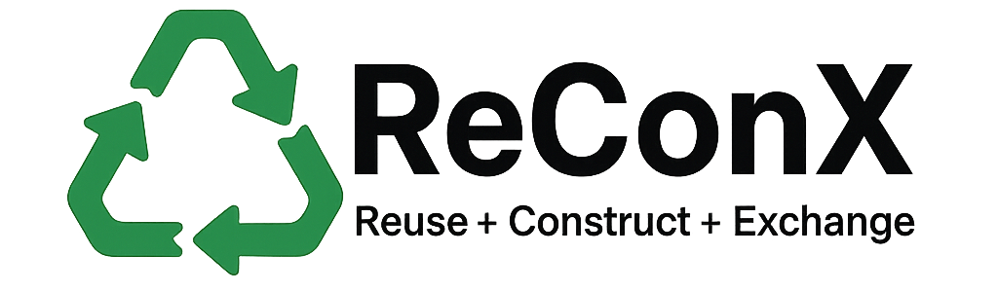
Privacy Policy
Effective Date: July 28, 2025
This Privacy Policy explains how ReConX ("we", "our", or "the Platform") collects, uses, discloses, and protects your information when you use our services through the website or web application.
By using the Platform, you agree to the collection and use of information in accordance with this policy.
1. Information We Collect
We collect the following types of personal and non-personal information:
a. Personal Information
- Full name
- Email address
- Phone number (optional)
- Organization or company name (if provided)
- Account role: Donor, Receiver, or Admin
- Location/address for pickup/drop-off coordination
b. Usage Data
- Pages visited
- Time and date of access
- Browser type and version
- IP address
- Clickstream and interaction logs

2. How We Use Your Information
We use collected data to:
- Create and manage user accounts
- Enable material listings and exchange functionality
- Match Donors with Receivers
- Send notifications and transaction-related emails
- Track environmental impact (e.g. carbon savings)
- Monitor platform activity for security and fraud prevention
- Improve platform performance and user experience

3. Sharing of Information
We do not sell or rent your personal information. Your data may be shared with:
- Other registered users for transaction purposes (e.g. name, contact info)
- Service providers for hosting, analytics, or communication (under strict confidentiality agreements)
- Legal authorities if required to comply with applicable laws

4. Data Storage and Security
We implement industry-standard security practices to protect your information. Data is stored on secure servers and access is restricted to authorized personnel only.
However, no method of transmission or storage is 100% secure. You use the Platform at your own risk.

5. Cookies and Tracking
We may use cookies and similar tracking technologies to enhance your browsing experience and collect usage analytics. You can control cookie settings in your browser.

6. Your Rights
You have the right to:
- Access your personal data
- Update or correct inaccuracies
- Request deletion of your account
- Withdraw consent for data processing (may limit platform use)
To exercise these rights, contact us at pathuhere10@gmail.com

7. Data Retention
We retain user data for as long as your account is active or as needed for legal, operational, or business purposes.

8. Children’s Privacy
Our platform is not intended for individuals under the age of 18. We do not knowingly collect data from minors.

9. Changes to this Policy
We may update this Privacy Policy from time to time. Any changes will be reflected on this page with an updated effective date. Continued use of the Platform after changes indicates your acceptance.

10. Contact Us
For questions or concerns about this Privacy Policy, reach us at:
📧 pathuhere10@gmail.com

